Project Design Phase
Solution Architecture
Date | 18 February 2026
Team ID | LTVIP2026TMIDS88973
Project Name | Civil Engineering Insight Studio
Maximum Marks | 4 Marks

Solution Architecture: Civil Engineering Insight Studio
Solution architecture for Civil Engineering Insight Studio is a structured framework that connects civil engineering project needs with intelligent AI and cloud-based technologies. It ensures that project data, site updates, reports, and insights are collected, analysed, and delivered efficiently through a centralized and user-friendly platform. This architecture helps engineers, project managers, and construction teams make faster and smarter decisions while improving project quality, safety, and efficiency.
Its goals are to:
● Identify the most effective AI and cloud technologies to solve civil engineering challenges such as project monitoring, data analysis, safety tracking, and real-time decision-making.
● Describe the overall structure and behaviour of the system, including how site data, voice/text updates, drawings, and reports flow through dashboards, AI analytics engines, backend processing systems, and secure cloud storage so stakeholders clearly understand how the solution operates.
● Define key features, development stages, and system requirements such as real-time monitoring, smart alerts, centralized dashboards, AI-based report analysis, voice and text input, data storage, and integration with construction management tools and cloud services.
● Provide clear technical specifications and architectural guidelines to ensure the solution is designed, implemented, and managed reliably using scalable cloud components such as artificial intelligence, IoT-based site monitoring, secure databases, and web/mobile interfaces for seamless project management.
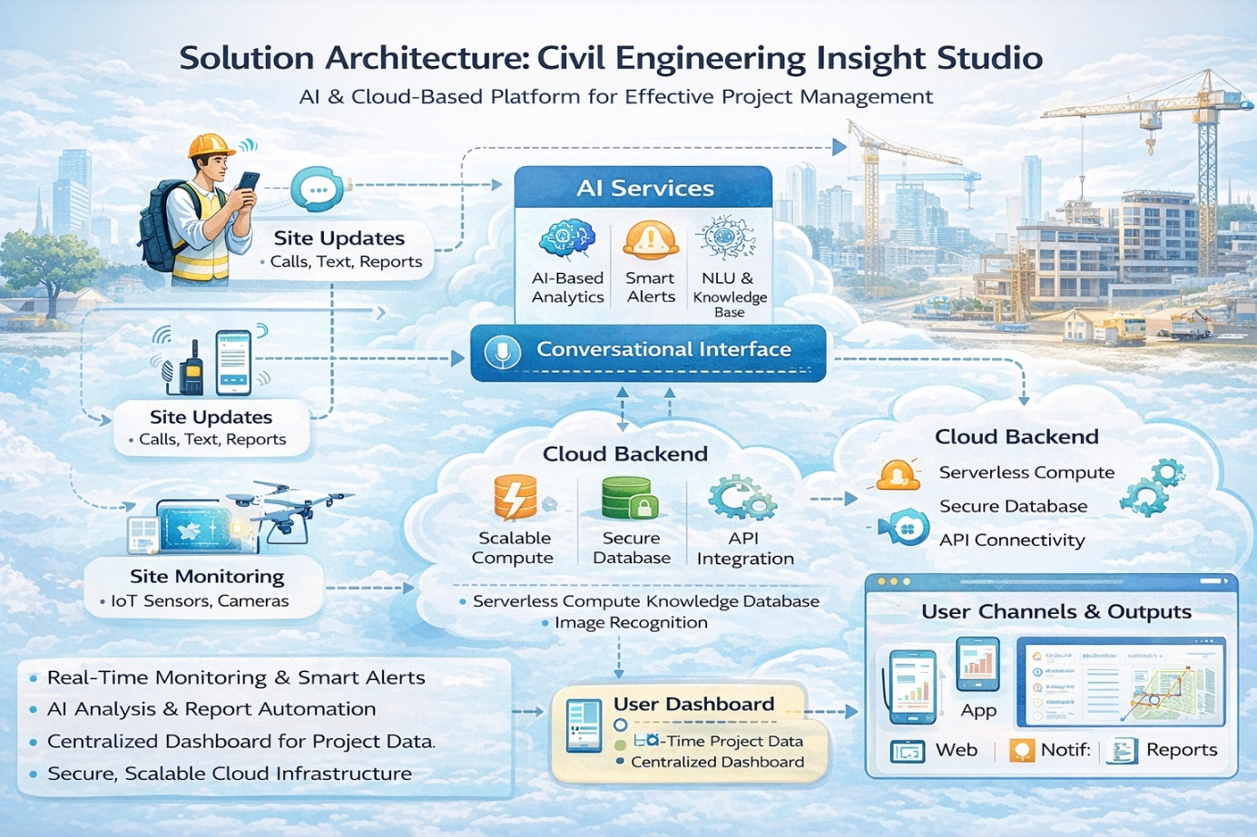
Figure 1: Architecture and data flow of the voice patient diary sample application

